Project Progress

Submission-3

Project Name: **Equation Solver**

Written By: **Alim Ul Karim**(**112 0821 042**) & **Alvee Rahman (**112 0350042)

Contacts: Alim Ul Karim [alim.karim.nsu@gmail.com](mailto:alim.karim.nsu@gmail.com) and +8801673175222

Alvee Rahman [alveeibnerahman@yahoo.com](mailto:alveeibnerahman@yahoo.com) and +8801824513578

On Going Progress:

Alim Ul Karim: I have managed to create small functions(such as: verify_number from char array, clean up an equation format and print it in a decent format, search in int array, search in char array etc..) to accomplish my job requirements.

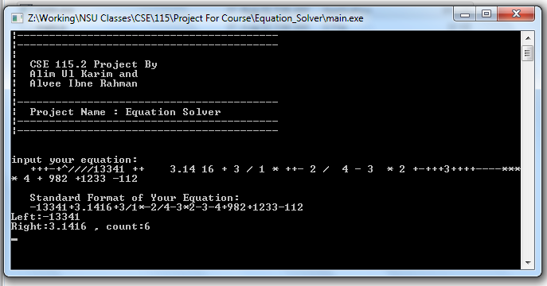

I made many clean up functions to standardize my equation as above image shows. There are some testing print out in the display like “Left ,right and count” which will not be in the screen when the program is deployed.

Currently I have been working on single token(‘+’ , ‘-‘ ,’*’ etc…) solution, If I could solve one token then the rest would be piece of cake. Project is now so much organized and I have managed to solve previous error, which consumed lots of time. I mostly used my own custom functions for every operation rather than using the library functions, however the project is in the .cpp file but I tried not to use any library from c++ other than cout.

Alvee Rahman : Communication gap.